CSCE 555 Project Report
Yee H. Wong (yxw0087)

Introduction

Round Robin (RR) is a popular scheduling algorithm in the field of computer science, every process in the ready queue takes turn to acquire CPU for some quantum time before switching to the next process. RR helps with reducing starvations of long processes compare to Shortest-Job-First, at the same time it prevents favoring long processes like in the case of First-Come-First-Served algorithm. Many modern operating systems implement some variance of RR for fair-share scheduling. Various modifications have been made to the original RR to fit in different needs of the operating system. One notable drawback of RR is when one process has just a little bit CPU burst time left but has used up the quantum time assigned to it; in this case, it will have to wait for all other processes in the ready queue to take their turns before it can finish its task. The intention of this project is to improve the performance of RR in terms of reducing the average waiting time of the processes as well as to increase the data throughput.

Proposal

In this project, instead of using a fixed quantum time for all the processes, I will adapt the idea of dynamic quantum in which a process may be allocated extra quantum time if its remaining CPU burst time is relatively low. The first idea that I tried was to calculate the quantum as square root of the mean run time of all processes in the ready queue, and if the remaining run time of a process is less than or equal to half of this quantum time, a bonus time is allocated to this process for as long as it needs to complete this last portion.
On the other hand, to ensure that short processes get released from the ready queue as soon as possible, I will do a sort on the ready queue before the first round starts. This is intended to increase the throughput by allowing short processes to finish earlier than long processes. However, this differs from SJF as each process will still be put at the end of the queue when it finished up its quantum time. Whenever a new process arrives, it will be sorted-insert into a proper place in the queue.
Even though priority scheduling should not be mixed with the concept of non-real time scheduling, in this project I have taken the consideration of a priority value for each process. The idea is that each process may have a different importance level associated with it and will be desirable to be run earlier than others. Therefore the ready queue is sorted not solely based on the run time of each process, but also based on this importance value. Precisely, the priority that is used to sort the queue is set to be the importance value of each process divided by remaining burst time of each corresponding process.

Modification

The project is implemented in NachOS (Not Another Completely Heuristic Operating System), which was developed at the University of California, Berkeley, and designed by Thomas Anderson. Nachos runs as a user-process on a host operating system and is written in C++ for MIPS. In my case, I have installed NachOS on CentOS which is one of the Linux distributions.
The original NachOS has only one scheduling algorithm which is the normal version of RR. When a thread is forked, it will be appended to the end of the ready queue. The function “FindNextToRun ()” will remove the first thread in the queue and run it for some time before calling “currentThread->Yield ()” which again puts this thread to the end of the queue and switch to the next thread.
To modify Nachos’ scheduler class for the purpose of this project, I changed the “ReadyToRun ()” function to do a sorted-insert to the ready queue instead of append (Figure 1). However, the content of “Yield ()” is not changed because it correctly implements the concept of RR.
Since this project does not use a fixed quantum time, I have added functions to calculate and retrieve the quantum time as shown in Figure 2. A private variable “priority” is also added to the thread class for sorting purpose.
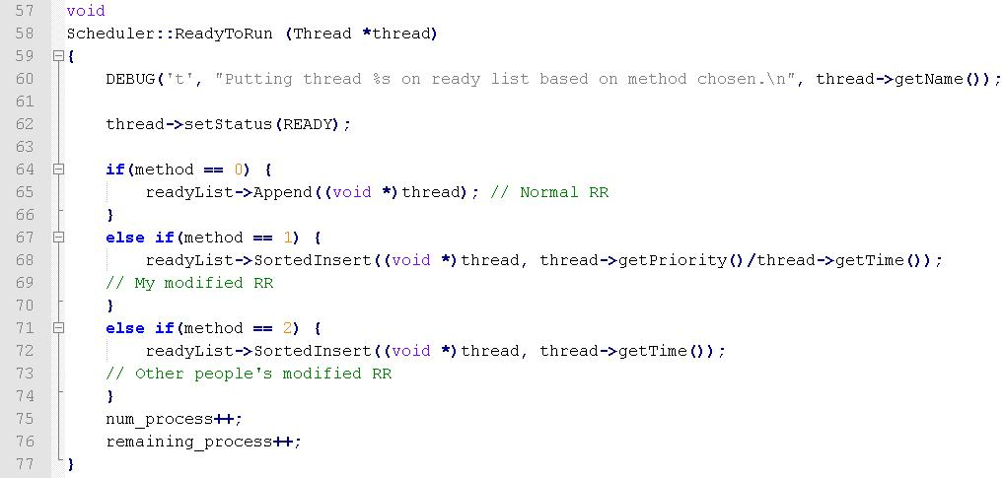
Figure 1
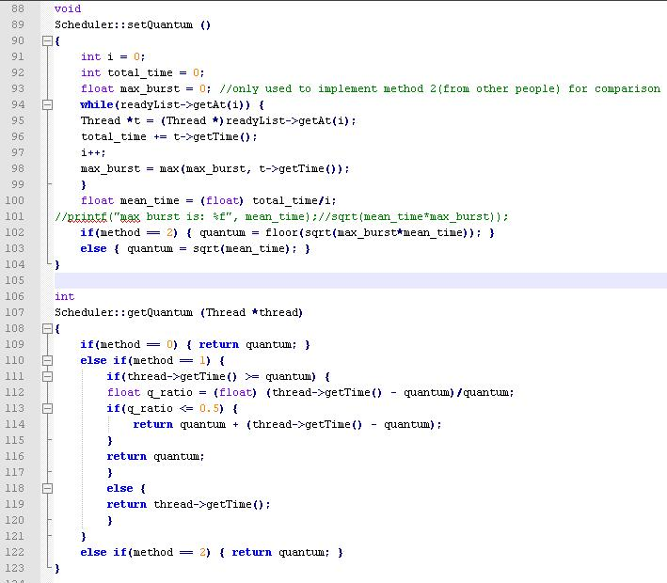
Figure 2

Testing procedure

The testing is carried out in the class threadtest.cc. Five randomly generated processes are created at time 0. In each round of the round robin, some new process can arrive randomly at a reasonable rate such that it will not cause an infinite incoming rate. Quantum time gets adjusted when and only when new process arrives.
To measure the waiting time and turnaround time of each process, I have added two arrays in scheduler.cc to keep track of how long each process has spent in waiting and how much time each process has taken to complete. When the last process in the queue has completed, “method_analysis ()” function is called to check the contents of these two arrays. Times will be calculated and printed to the screen along with how many context switches were observed in the whole process.
A new command line option was implemented for easier switching between which scheduling algorithms to use for testing. For example, ./nachos -0 will run the original RR while ./nachos -1 will run the customized RR designed in this project.

Results

After running the project on several types of processes, I observed that the original RR algorithm performs better on processes that have shorter run time (less than 200 clock ticks). However, as the overall run time increases, the modified version of RR designed in this project began to produce a better data throughput with the cost of slightly higher number of context switches. 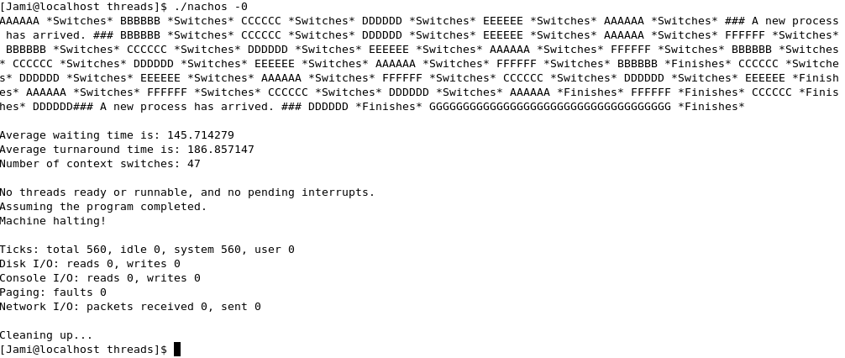
Figure 3 - Test Run With Original RR (Short Run Time)
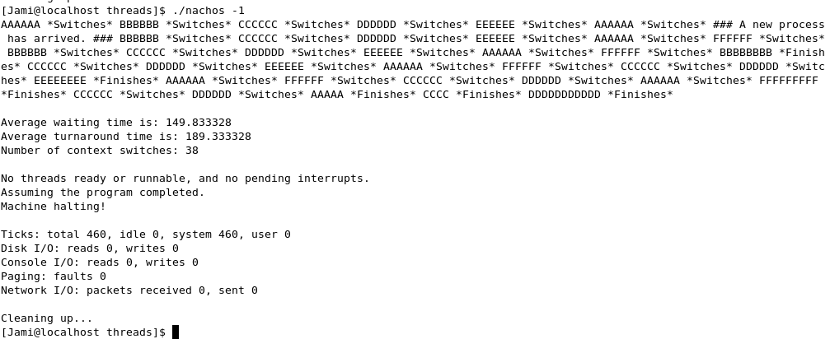
Figure 3 - Test Run With Modified RR (Short Run Time)

Figure 4 illustrates a sample test output when the project was run on randomly generated incoming processes that have random run times between 100 to 999 clock ticks.
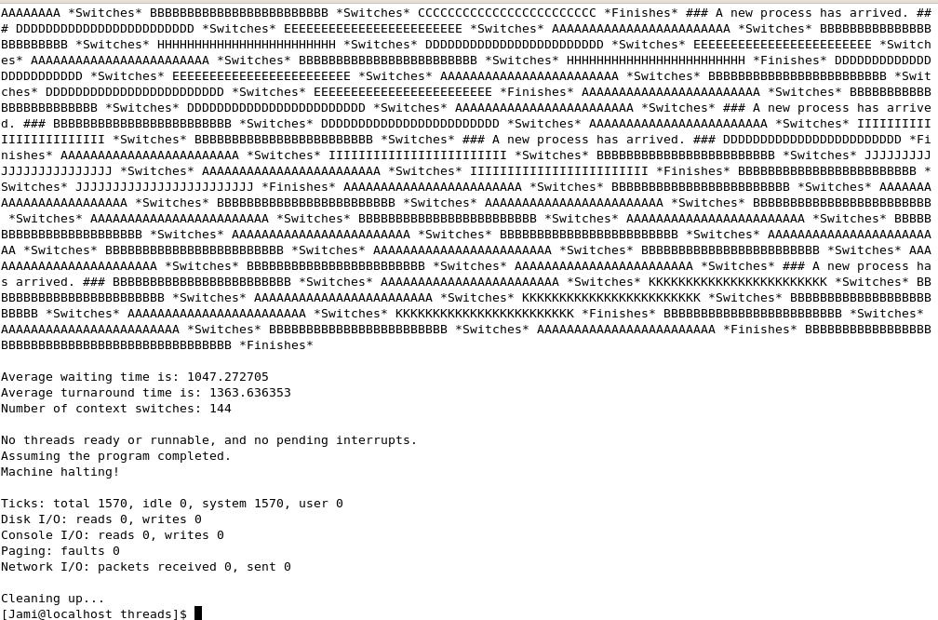
Figure 4 - Test Run With Original RR (Long Run Time)

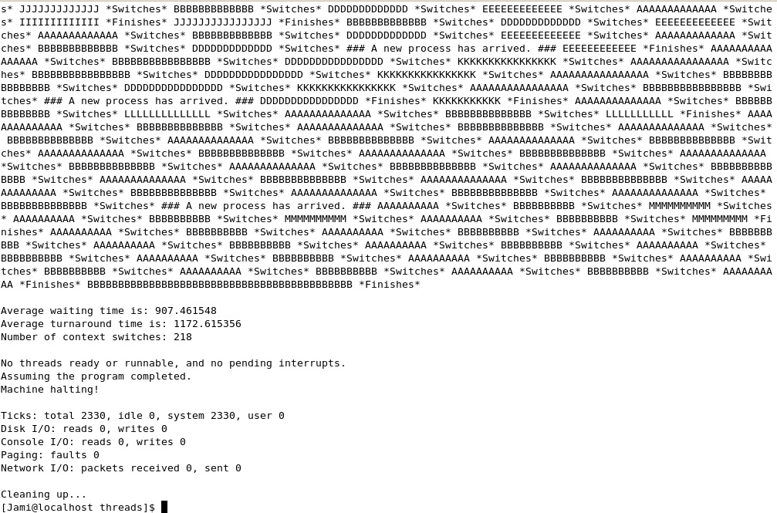
Figure 4 - Test Run With Modified RR (Long Run Time)

Limitations

Based on the observed results, the modified version of RR would be desirable only when we have longer running times for most of the processes and if context switch takes less than two clock ticks.
This method still suffers from problems such as when all processes have the same running time which will produce abysmal data throughput as in the case of normal RR.
The above tests were done based on the idea of uniprocessor. In the case of multiprocessor, this method will still share the same benefits as seen in normal RR such as increase in throughput and decrease in waiting time.

Related Works

Many similar approaches have been done and presented by various authors in their papers. For instance, Yaashuwanth and Ramesh presented “Shortest Round Robin” and “Intelligent Time Slice Round Robin” in 2012 (1). Similarly, Ishwari Singh Rajput and Deepa Gupta came up with “Priority Based Round Robin” in their research paper (2). In 2014, Radhe Shyam and Sunil Kumar Nandal proposed “Improved Mean Round Robin with Shortest Job First Scheduling” (1), which used the approach of sorting the ready queue first and then set the quantum time to square root of (mean run time*highest burst). As part of the project, this method was implemented for comparison purpose and can be run by typing ./nachos -2 to the terminal. It was observed that this method allocates a much larger quantum time to each process and requires less context switches with the cost of higher waiting time compared to the method designed in this project.

References

1. C.Yaashuwanth and Dr.R.Ramesh. A New Scheduling Algorithms for Real Time Tasks. International Journal of Computer Science and Information Security, Vol. 6, No.2, 2009.

2. Ishwari Singh Rajput and Deepa Gupta. A Priority based Round Robin CPU Scheduling Algorithm for Real Time Systems. International Journal of Innovations in Engineering and Technology, Vol. 1 Issue 3 Oct 2012.

3. Radhe Shyam and Sunil Kumar Nandal. Improved Mean Round Robin with Shortest Job First Scheduling. International Journal of Advanced Research in Computer Science and Software Engineering, Volume 4, Issue 7, July 2014.

End of report.

